|  |  |
| --- | --- |
| **MY BIBLE STORY** | **Deborah the prophetess** |

|  |
| --- |
| **By Vivian Nzubechi Nathaniel |** |

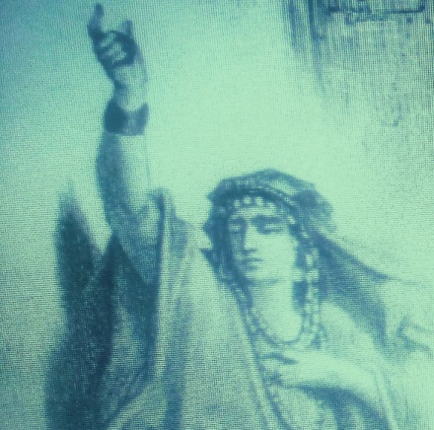

**Copyright**

**FORWARD**

**The story about Deborah is so fascinating that it worth your time to read and study about her outstanding qualities. The characters she possessed cannot be left unnoticed.**

**You could wonder why how she stood strong in the mist of men of her time.**

**Who was Deborah?**

**Why is it important to learn about her?**

**OWLEDGEMENT**

**I appreciate the presence of the Holy Spirit, my teacher for the wisdom he infused in me to pen down this piece of wisdom.**

**May the Lord be magnified forever, Amen!**

**CHAPTER 1**

**DEBORAH AND HER NAME**

**Picture of Deborah**

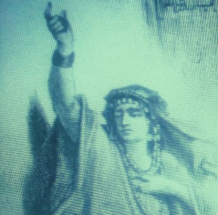

**Deborah (Devorah or D’vorah in Hebrew) is translated as “bee.”**

**The Midrash (a collection of teachings on the Torah) explains that the Hebrew people are said to be like bees in several ways:**

**1. Just as bees follow their leader in a swarm, the Jewish people follow the sages and prophets to teach them.**

**2. As a bee sting is quite painful, but the bee’s honey is incredibly sweet, God’s Word will sting those who don’t follow His commands but will bless those who live righteously with a sweet life.**

**3. Bees collect pollen and nectar, not for their own benefit, but for the benefit of others, just as the Hebrews collect mitzvahs (a good deed done for others or religious benefit) for the Lord’s pleasure and benefit.**

**4. Bees are a lowly insect, which is a reminder to God’s children to be humble.**

**CHAPTER 2**

**INTRODUCTION**

**Deborah is one of the most influential women in the Bible. She is mainly known as a prophetess and a judge in Israel. Her story is primarily found in the Book of Judges, specifically in Judges 4 and 5.**

**As a prophet, Deborah was said to hear God's voice and share God’s Word with others. As a priestess, she did not offer sacrifices, as the men did, but she did lead worship services and preach.**

**Many biblical scholars believe that Deborah was a wife, as well.  However, in Hebrew, the same word is used for “woman” and “wife,” so we don’t know, with certainty, if Deborah was a “woman of Lappidoth” (a place) or the “wife of Lappidoth” (a person).**

**CHAPTER 3**

**WHAT ROLE DID DEBORAH PLAY**

**Deborah's role as a judge and prophetess**

**Deborah served as a judge during a time when the Israelites were oppressed by the Canaanites. Judges in ancient Israel were leaders raised up by God to deliver the people from oppression and to administer justice. Deborah was known for her wisdom, and the Israelites would come to her to settle disputes and seek guidance.**

**Deborah was one of the rulers of the Hebrews (and the only female leader) in the Old Testament. These rulers were called “mishpat,” which is translated as “judges.” This role was originated back when Moses appointed helpers to assist him in resolving arguments among the people. Exodus 18.**

**Judges sought guidance from the Lord by praying and meditating before proclaiming their ruling on a matter.  Many judges were also considered prophets who articulated "a word from the Lord."**

**Deborah would sit under the palm tree between Ramah and Bethel in the hill country of Ephraim, and the Israelites would line up for her to rule on a matter.**

**CHAPTER 4**

**AS A MILITARY LEADER**

**One of the most famous aspects of Deborah's story is her role in leading the Israelites in a military campaign against the Canaanite general Sisera. Under her guidance, the Israelite forces, led by Barak, won a significant victory over the Canaanites at the Battle of Mount Tabor. Sisera, the Canaanite general, fled the battle and sought refuge in the tent of a woman named Jael, where he was eventually killed.**

**Upon receiving instructions from God, Deborah called Barak, an Israelite warrior, to bring 10,000 troops up Mount Tabor to attack Sisera, Jabin’s commander of troops.**

**Barak responded by saying, "If you will go with me, I will go; if not I will not go" (Judges 4:9).**

**In the next verse, Deborah agrees to go to battle with Barak and the troops but shares with him: "However, there will be no glory for you in the course you are taking, for then the Lord will deliver Sisera into the hands of a woman" (Judges 4:9). Judge and warrior Deborah went off to battle with Barak, and, as foretold in prophecy, Sisera fell at the hands of a woman – but not Deborah. Rather it was Jael, the wife of a clan leader, who would avenge the Israelites by driving a tent peg through Sisera’s head with a mallet when he asked for water and respite.**

**Biblical commentaries and scholars disagree on Barak’s acceptance of Deborah’s battle leadership. Some feel that Barak respected her as a leader and prophetess and willingly heeded her call. Others, however, concluded that his response in Judges 4:8 pointed to his discomfort in taking orders from a woman despite the esteem she is held in.**

**CHAPTER 5**

**SONGS OF DEBORAH**

**After the battle, Deborah composed songs of victory, which is recorded in Judges 3. This song, often called the "Song of Deborah," celebrates the triumph of the Israelites over their oppressors and praises God for His role in the victory. This chapter in Scripture is believed to have been written as early as the 12th century BC and is considered by many biblical scholars as one of the earliest examples of Hebrew poetry.**

**This poetry celebrates the Hebrew’s victory over the Canaanites and Sisera’s army.**

***"When the princes in Israel take the lead, when the people willingly offer themselves- praise the LORD! Hear this, you kings! Listen, you rulers! I, even I, will sing to the LORD; I will praise the LORD, the God of Israel, in song. When you, LORD, went out from Seir, when you marched from the land of Edom, the earth shook, the heavens poured, the clouds poured down water. The mountains quaked before the LORD, the One of Sinai, before the LORD, the God of Israel."* Judges 5:2-5.**

***“Wake up, wake up, Deborah! Wake up, wake up, breakout in song! Arise, Barak! Take captive your captives, son of Abinoam. The remnant of the nobles came down; the people of the Lord came down to me against the mighty… So may all your enemies perish, Lord! But may all who love you be like the sun when it rises in its strength.”* JUDGES 5:12,13,31.**

**CHAPTER 6**

**LESSONS**

**Deborah and her story can teach us so much. There are three lessons we can all learn from in this story;**

**1. Be Obedient**

**If God is telling you to do something or go somewhere, despite your fears and the feeling of unworthiness always listen and obey His call. He has plans that we cannot begin to understand, and hearts and lives may be changed by our obedience.**

**2. Be Courageous**

**The old saying "God doesn't call the qualified, He qualifies the called"   applies here.  Doing something out of your comfort zone to glorify Him can be terrifying, but faith was never promised to be easy.  Be bold. Be courageous - for His glory.**

**3. Stand True**

**May you never waiver or give up on your faith for any reason at all. We may not always know what the road ahead will look like, but we only need to remember that God will faithfully guide us and lead the way.**

**Deborah's story in the Bible serves as an example of a woman who played a key leadership role during a crucial period in Israel's history and is remembered for her wisdom, prophetic insight, and courage in times of crisis.**

**CONCLUSION**

**In the Bible, Deborah is presented as a prophetess, judge, and military leader in the Book of Judges (chapters 4 and 5). She is the only female judge mentioned, and her story highlights God's ability to use anyone, regardless of gender, to lead and deliver His people. Deborah's story is unique because it is told in both prose (chapter 4) and poetry in the song of Deborah in chapter 5 of the book of Judges.**

**In today’s, men usually question the powers God invested in women for his service. The answer is very clear and precise. Just as it is written that there are many vessels in God’s house, so are God’s grace on peoples differs. 2Timothy 2:20.**

**We should not forget also that the excellency of the power we possess is not our own but it all belongs to God. 2Corinthians 4:7. All the glory belong God who is the giver of every good gifts such as the gifts of nature and perfect presents.**

**To the only wise God be glory forever and ever, Amen!**